**Sherlock Scenario**:

The IDS device alerted us to a possible rogue device in the internal Active Directory network. The Intrusion Detection System also indicated signs of LLMNR traffic, which is unusual. It is suspected that an LLMNR poisoning attack occurred. The LLMNR traffic was directed towards Forela-WKstn002, which has the IP address 172.17.79.136. A limited packet capture from the surrounding time is provided to you, our Network Forensics expert. Since this occurred in the Active Directory VLAN, it is suggested that we perform network threat hunting with the Active Directory attack vector in mind, specifically focusing on LLMNR poisoning. - Hackthebox.com/sherlocks/Noxious/play

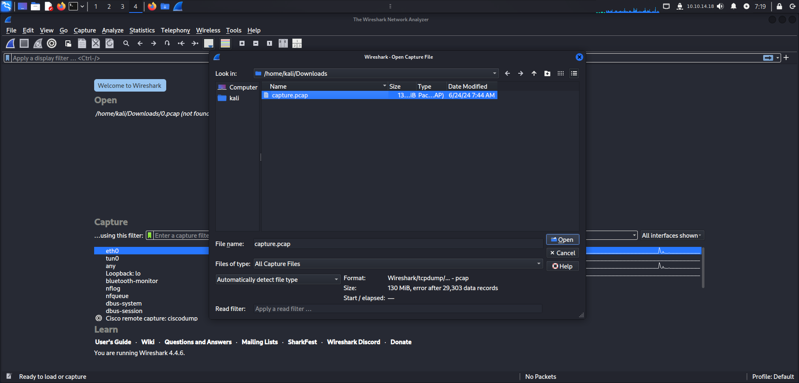

We start by uploading the .pcap file on wireshark.

Task 1. *It’s suspected by the security team that there was a rogue device in Forela's internal network running responder tool to perform an LLMNR Poisoning attack. Please find the malicious IP Address of the machine.*

Knowing LMNR operates on UDP:5355 we filter on wireshark with “udp.port==5355”

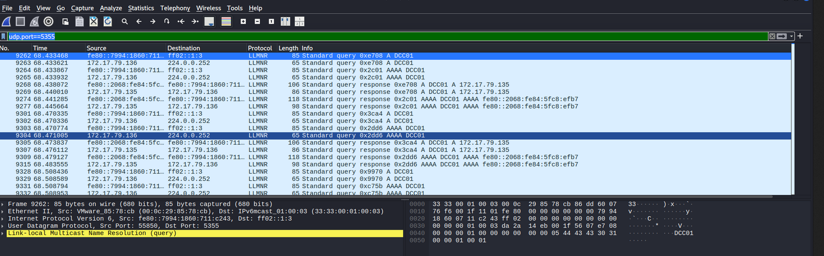

So, LLMNR (Link-Local Multicast Name Resolution) poisoning is a type of cyberattack that exploits a vulnerability in the LLMNR protocol, a component of Microsoft Windows used for name resolution on local networks when traditional DNS fails.

Based on this and the question, we need to search something related to Forela’s internal network.

We orded the packets by info, and we find the answer to our first question: “Source Address: 172.17.79.135”

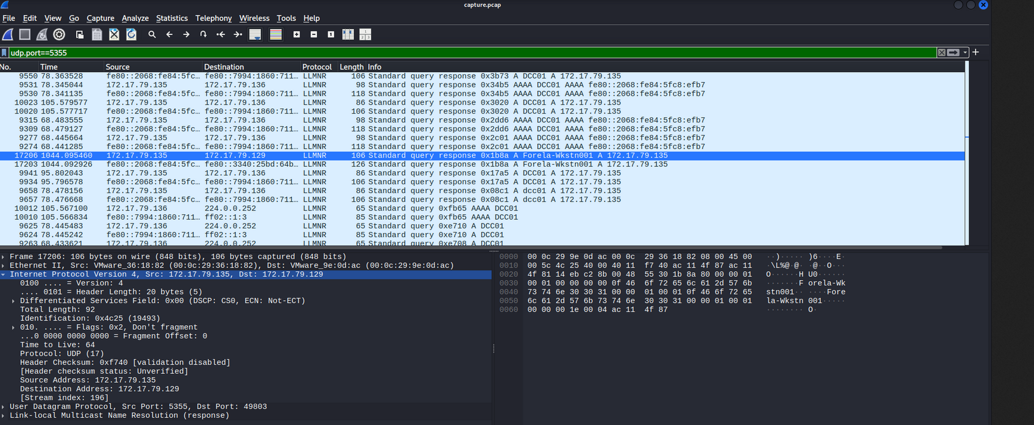

Task 2. *What is the hostname of the rogue machine?*

Now that we know the ip address we can filter by ip address and DHCP with “ip.addr==172.17.79.135 && dhcp”

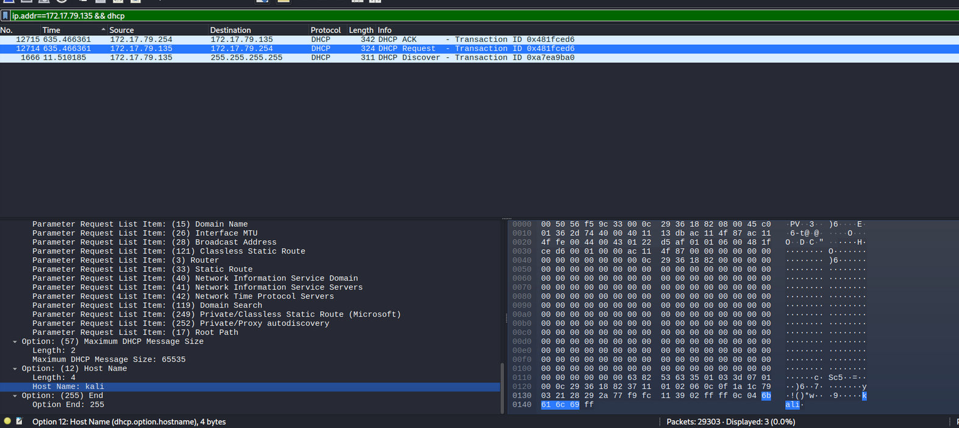

The DHCP process typically follows a four-step exchange, often referred to as DORA but here we have only 3 (DHCP offer is missing) so we look into the Dynamic Host Configuration Protocol (Request), and we fiind the name of the rogue machine.

Task 3. *Now we need to confirm whether the attacker captured the user's hash and it is crackable!! What is the username whose hash was captured?*

When dealing with LLMNR poisoning and the subsequent capture of NTLM hashes, you need to look into SMB (Server Message Block) traffic because **SMB is one of the most common protocols that uses NTLM authentication, especially for file sharing and other network services in Windows environments.**

So we need a filter to show only smb2 traffic in order to see if the hash has been captured.

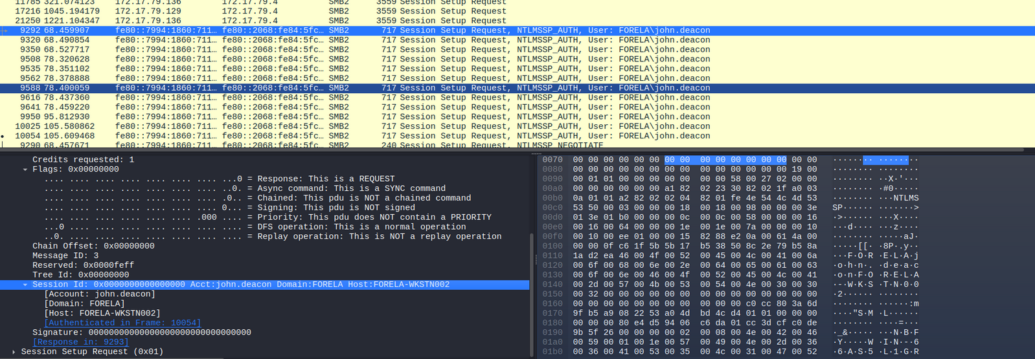

A session was created to most certainly the hash has been captured.

Then we need to see the name of the user, we add && ntslm on the filter and find this packet with the name of the user.

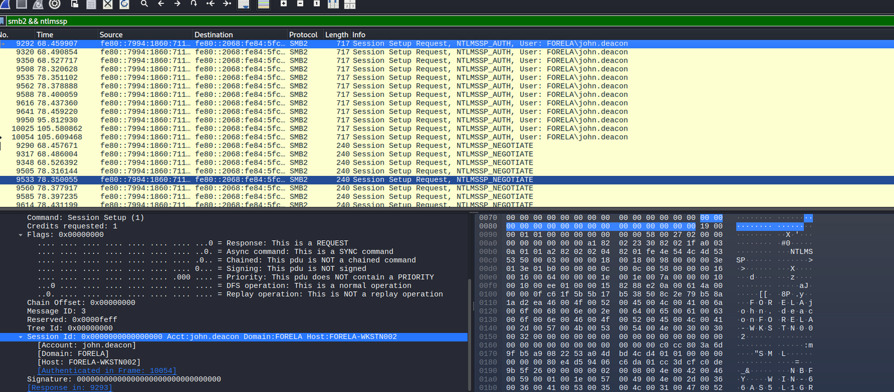

Task 4 *In NTLM traffic we can see that the victim credentials were relayed multiple times to the attacker's machine. When were the hashes captured the First time?*

So we need to see the first 3 packets captured that end in an NTLMSSP_AUTH and take the date and time.

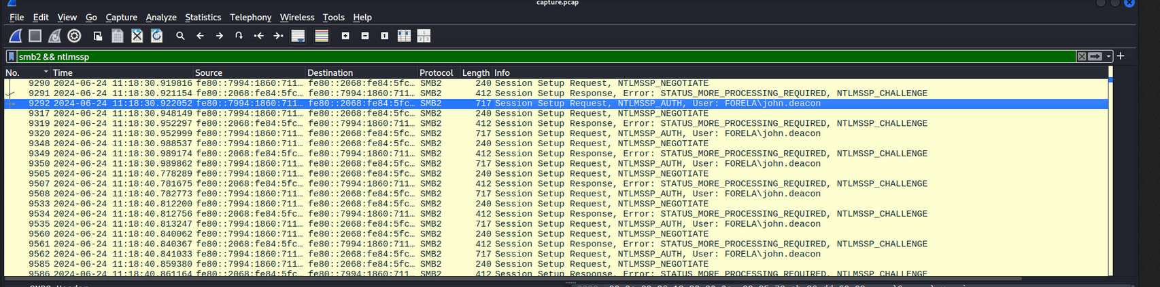

Task 5 *What was the typo made by the victim when navigating to the file share that caused his credentials to be leaked?*

Here I had to use the hint because I was not quite sure what the question was about.

We need to filter base on the victim machine and llmnr traffic.

*ip.addr==172.17.79.136 && llmnr*

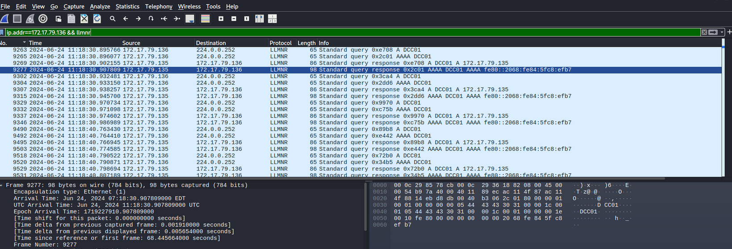

Based on the hint, we see that the victim typed DCC01 instead of DC01.

Task 6 *To get the actual credentials of the victim user we need to stitch together multiple values from the ntlm negotiation packets. What is the NTLM server challenge value?*

We need to filter based on ntlmssp traffic and search for ntlmssp_challenge.

Here we navigate to SMB2 (Server Message Block ProtocolVersion 2) -> Session Setup Response (0x1) -> Security Blob -> GSS-API Generic -> SimpleProtected Negotiation -> negTokenTarg -> NTLM Secure Service Provider -> NTLM Server Challenge and find the value.

Task 7 *Now doing something similar find the NTProofStr value*

We keep the filter and go to the auth package and navigate SMB2 (Server Message Block Protocol Version 2) -> Session Setup Response (0x1) -> Security Blob -> GSS-API Generic **** -> Simple Protected Negotiation -> negTokenTarg -> NTLM Secure Service Provider -> -> NTLM Response -> NTLMv2 Response -> NTProofStr. To find the value

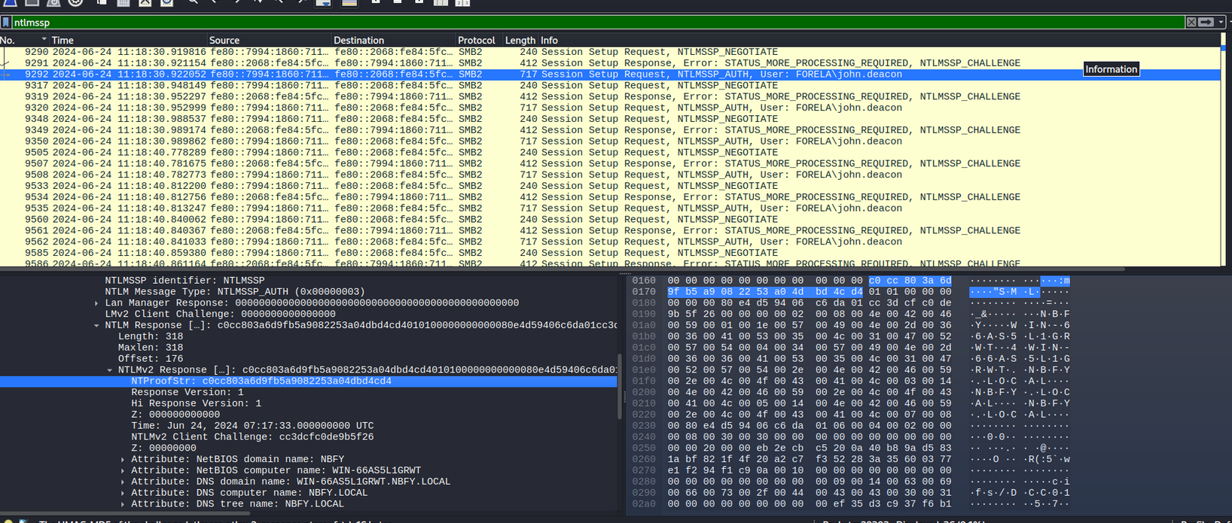

Task 8 *To test the password complexity, try recovering the password from the information found from packet capture. This is a crucial step as this way we can find whether the attacker was able to crack this and how quickly.*

First we need to create a file with the following lines:

User::Domain:ServerChallenge:NTProofStr:NTLMv2Response

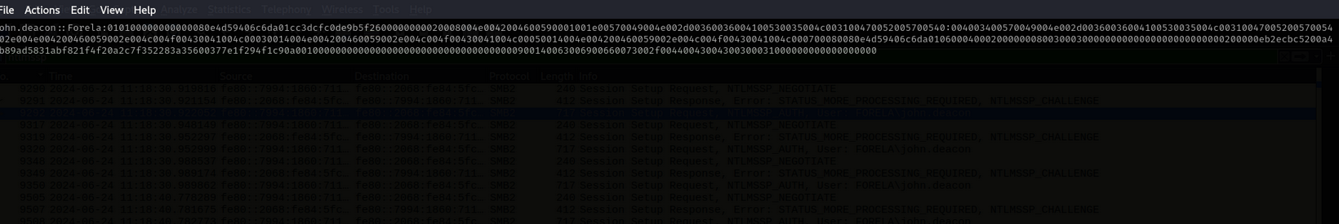

We create a file and edit with vi then we feed the file to hashcat.



Task 9 *Just to get more context surrounding the incident, what is the actual file share that the victim was trying to navigate to?*

Filtering again for smb2 traffic.

.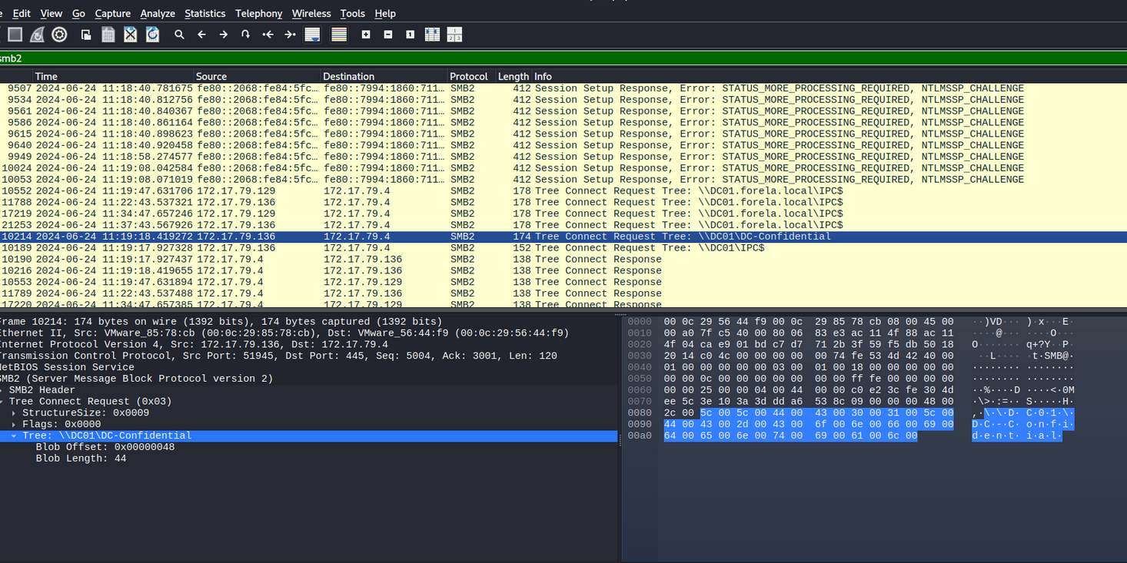

This looks odd, a confidential file share…

